**CMPE 277 - Homework #5: Security**

**Part A: Configure Apache Web Server on Amazon Linux to Use SSL/TLS**

* Launched an EC2 instance with Amazon Linux 2 AMI

* Allowed inbound ports: 22 (SSH), 80 (HTTP), 443 (HTTPS)

* Verified public IP and instance status: Successful SSH connection

**Step 2: Install Apache and SSL Module**

* Executed the following:

sudo yum update -y

sudo yum install -y httpd mod_ssl

**Step 3: Start Apache and Enable on Boot**

* Executed the following:

sudo systemctl start httpd

sudo systemctl enable httpd

**Step 4: Generate a Self-Signed SSL Certificate**

* Executed the following:

sudo openssl req -x509 -nodes -days 365 \

-newkey rsa:2048 \

-keyout /etc/pki/tls/private/selfsigned.key \

-out /etc/pki/tls/certs/selfsigned.crt

**Step 5: Configure Apache SSL Settings**

Executed the following:

* Edited the file:

sudo vi /etc/httpd/conf.d/ssl.conf

* Updated paths:

SSLCertificateFile /etc/pki/tls/certs/selfsigned.crt

SSLCertificateKeyFile /etc/pki/tls/private/selfsigned.key

**Step 6: Restarted Apache and Verified HTTPS Access**

* Executed:

sudo systemctl restart httpd

* Browser showing HTTPS connection (with SSL warning)

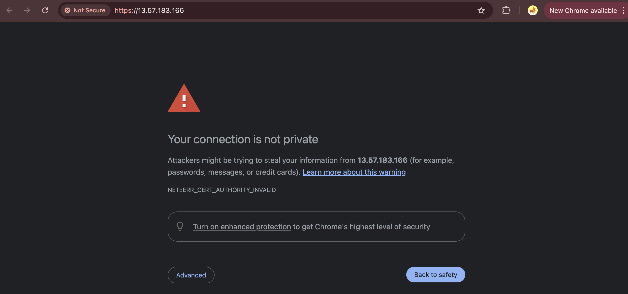

**Step 7: Attempted SSL Labs Analysis**

Visited: https://www.ssllabs.com/ssltest/analyze.html

**Part B: Use IAM Role to Grant Access to S3 from EC2**

**Step 1: Create IAM Role with S3 Read-Only Access**

* Created role: EC2S3ReadOnlyRole
* Attached policy: AmazonS3ReadOnlyAccess

**Step 2: Attach IAM Role to EC2 Instance**

* Attached EC2S3ReadOnlyRole to EC2 instance using EC2 Console

**Step 3: Upload File to S3 Bucket**

* Created bucket: my-s3-accessec2-test-bucket
* Uploaded file: test.txt

Step 4: Install AWS CLI and SDK

**Step 5: Create and Run Sample Program on EC2**

* Used the following Python script:

* Executed the following:

python3 s3_list.py

* Successful output listing test.txt

